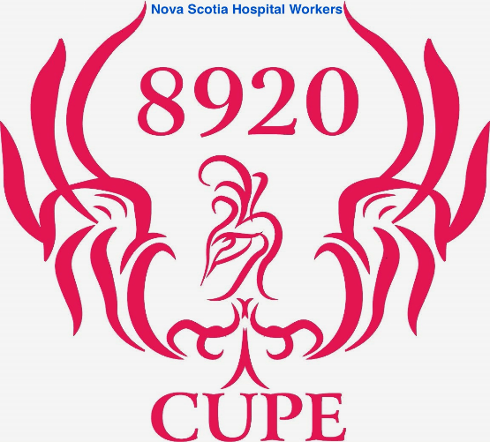

AP Membership CUPE update

As we are aware the Council of Nursing Unions were successful in reaching a tentative agreement with Nova Scotia Health and that tentative agreement was successfully ratified. That leaves only our Administrative Professional bargaining unit without a new collective agreement since the expiry of the current collective agreements on Oct 31, 2020.

As we know the Council of Healthcare Unions signed their new collective agreement in November 2021 and the Council of Health Support Unions signed theirs in August 2022. Both of these agreements will expire three months from now on October 31, 2023.

The Council of Nursing Unions collective agreement that was agreed to yesterday has two more years added onto it and will not expire until October 31, 2025. The economic adjustments for those two years will be 3% on Oct. 31, 2023 and another 2% on Oct. 31, 2024. The Admin Professional bargaining team does not know if that offer or any other offer at this point, will come forward to our bargaining table.

The crux of our concern, at this point, is finding an agreement on an Essential Service plan with the Employer. The Employer is not following the Essential Health and Community Service Act which was enacted by Premier Steven McNeil in 2014.

The Act in Section 2 subsection (1) mandates that we agree on the number of Employees who must remain in the workplace if job action is initiated. The Act itself defines essential health and community service as “a health or community service, duty or function that is necessary to enable the employer to prevent or limit:
- Loss of life
- Serious harm or damage to or deterioration of the mental or physical health of one or more persons
- Serious harm or damage to or deterioration of property required for the performance of an essential health or community service in relation to bullet one and two.
The Act then goes on to state in Section 5 subsection (2) how the essential service plan is to be negotiated. Subsection 2(b) states that the Employer must identify the classification of Employees, and the number of Employees in each classification, who are required at any one time to perform essential health services during a strike.

This is where the disagreement comes forward between the Unions and the Employer. The Employer has supplied the Unions with the number of full-time equivalents (FTE’s) it needs to staff the facilities should a strike occur.

An FTE does not represent an Employee rather a number of hours. A 1FTE over a week would be 35 hours of work. In the FTE world of the Employer that could mean two people working seven-hour shifts on Monday or Tuesday and one person working a shift on Wednesday. It could mean one person working 7.5 hours each day or seven members working five-hour shifts in one day. There is no way for the Unions to decipher how many members could/would be scheduled to be in the facility at any one time.

We met with the Employers on June 21 and July 19 trying to find a resolve to the issue. It is unfortunate but the Employer will not relent and supply the Unions with numbers of Employees as opposed to FTE’s.

The Essential Health and Community Service Act allows a dispute mechanism if an agreement can not be reached. For our purpose Section 7 (1) of the Act states that each Employer and each bargaining agent for the Employees of the Employer shall endeavor to reach an essential health and community service agreement through negotiations.

Section 8 of the Act allows for a complaint mechanism to the Nova Scotia Labor Board. The Unions have chosen that path stating that the Employer has not complied with Section 7 (1) of the Act. The Board will look at the complaint, it may dismiss the complaint, or it may file an order to either party to do anything necessary to insure compliance of the Act. Section 8 (2) must be resolved by the Labor Board within three business days.

We can not take any job action until an essential service agreement is in place so once this hurtle is settled, we can move forward with negotiating an essential service agreement either way the Board decides. That truly is the hold up to your bargaining team.

We have received funding from CUPE National for a strike aversion campaign. We will use that funding, in conjunction with the other unions, to commence radio ads, develop a social media presence and purchase “swag” so that the Employer will not be able to forget we are here.

Truly, until the essential service piece is completed the Employer knows the Admin Professional bargaining unit cannot legally commence any type of job action. Therefore, it appears, they are in no hurry to call your bargaining team back to the bargaining table.

Once the Employee vs FTE issue is decided or ruled on by the Nova Scotia Labor Board, we will move very quickly towards trying to negotiate an actual essential service agreement.

The bargaining team will continue to update you as things move forward and new information comes to light.

